Use parameter to flag as a vendor log in or customer log in - Addressing two dif logins

Error message for add menu items

Clean up validation msgs

Search function by name

Image uploading

Set to lowercase

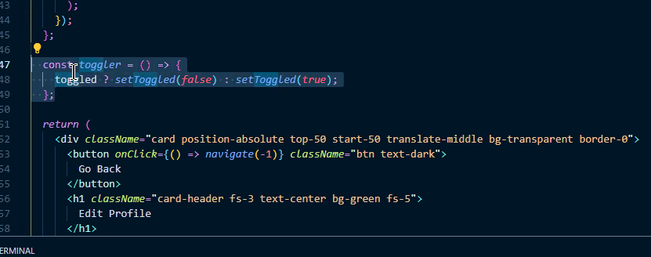

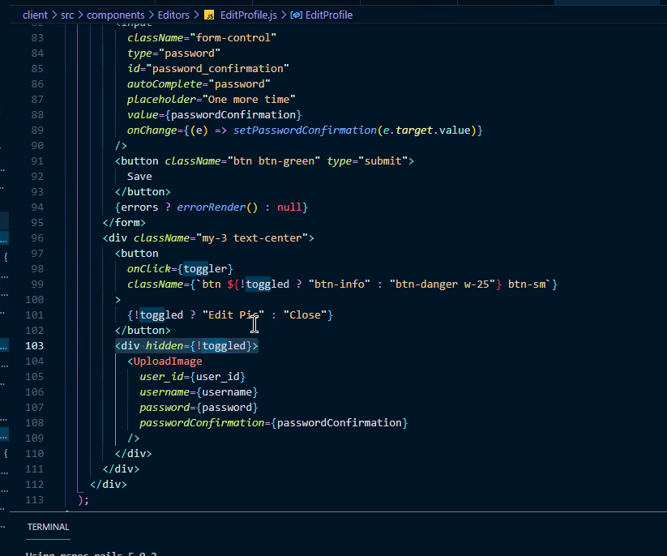

const capitalize = (str) => {

if(typeof str === 'string') {

return str.replace(/^\w/, c => c.toUpperCase());

} else {

return '';

}

};

capitalize('google') // Google